


Computer Communications 26 (2003) 1782–1791

www.elsevier.com/locate/comcom

A distributed simulator for network resource management investigation

Josep L. Marzo*, Pere Vila`, Lluıґs Fa`brega, Daniel Massaguer

Institut d’Informa`tica i Aplicacions (IIiA), Universitat de Girona, Lluis Santaloґ Av., 17071 Girona, Spain

Abstract
Network resource management deals with protocols and networks capable of performing a reservation of the available resources in
order to guarantee a certain Quality of Service (QoS). Examples of these technologies are Asynchronous Transfer Mode (ATM) and
Multi-Protocol Label Switching (MPLS), which are usually used in core networks. An important objective of network providers is to
obtain the maximum proﬁt from their resources; hence there is a need for an efﬁcient resource management. Investigation in this ﬁeld is
difﬁcult, mainly because network research laboratories do not have a large core network where they can investigate their approaches and
algorithms.
This paper presents a simple but ﬂexible distributed simulator that supports a wide range of different experiments. It is based on an
event-oriented simulation at a connection level (no packet or cell granularity). The distributed simulator is oriented to the simulation
of large core networks and support different routing and admission control algorithms. The simulator must also support
the development of different resource management architectures: centralised, distributed, hybrid, based on artiﬁcial intelligence
techniques, etc.
The paper also presents the scenario where this simulator can be used, mainly in the context of Trafﬁc Engineering, i.e. dynamic
bandwidth management and fast restoration mechanisms. Examples of different management applications and experiments performed
using the simulator are presented.
q 2003 Elsevier B.V. All rights reserved.
Keywords: Distributed simulation; Client/server network management and control; Multi-Protocol Label Switching; Asynchronous Transfer Mode

1. Introduction

Although the technology of the present-day networks
offers users increasing transmission capacity, the fact is that
the increase in the amount of data to be transmitted is higher
than the network capacity. This is due to the high increase in
the number of new users and the appearance of new services
(multimedia and interactive resource-consuming services).
Therefore, it is clearly necessary to use network resources
efﬁciently.
Large telecommunication companies have been using
powerful network management tools, usually based on
standards, which provide network statistics and analysis
tools to help human network managers in decision-making.
These centralised decision-making could suffer a scalability
problem when excessive network monitoring trafﬁc arises.
Moreover, these tools are designed to perform manual

* Corresponding author. Tel.: ю 34-972-418497; fax: ю34-972-418098.
E-mail addresses: marzo@eia.udg.es (J.L. Marzo), perev@eia.udg.es
(P. Vila`), fabrega@eia.udg.es (L. Fa`brega), dmassa@eia.udg.es (D.
Massaguer).
0140-3664/03/$ - see front matter q 2003 Elsevier B.V. All rights reserved.
doi:10.1016/S0140-3664(03)00051-3

network management or, at the most, to carry out some
actions at pre-set hours of the day.
By using certain network management technologies the
network adapts itself automatically under different levels of
load in a dynamic way.
Generally network management encompasses a broad
range of tasks that are summarised in the so-called FCAPS
(Fault, Conﬁguration, Accounting, Performance, and Secur-
ity) management areas. The ﬁeld of resource management
deals mainly with Performance and Fault management, and
more speciﬁcally with dynamic bandwidth management and
fault protection mechanisms [1,2].
This paper presents a distributed simulator to investigate
network resource management. Simulation is a crucial tool
in the investigation and evaluation of different mechanisms
or techniques to perform this resource management. The
investigation is focused on automatic tools, several of which
are partially or totally distributed. The simulator itself is
also distributed in order to facilitate the development and
testing of these mechanisms.
Section 2 presents the background and the environment
where these resource management techniques can be

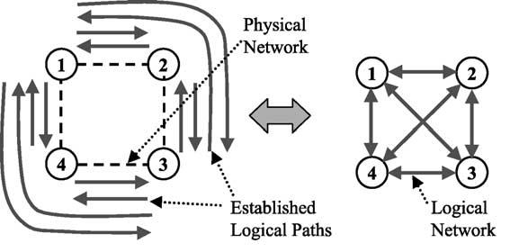
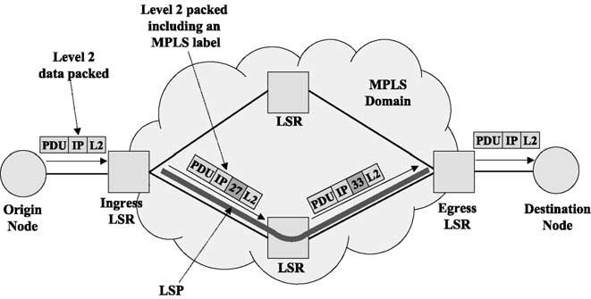

J.L. Marzo et al. / Computer Communications 26 (2003) 1782–1791

1783

applied and details the main idea to perform this manage-
ment, i.e. the logical network. It also introduces two
network technologies that have mechanisms to establish
and manage a logical network. Section 3 focuses on what
are the speciﬁc actions that must be carried out by network
resource management (i.e. fault protection and dynamic
bandwidth management) and that the distributed simulator
must support. Section 4 presents some related work, gives
references to other simulation tools and points out the main
differences with our proposal. Section 5 details the
simulator design and its main characteristics. Section 6
presents several simulation scenarios for the evaluation of
the simulator behaviour, using different management
applications that we have developed. Finally, Section 7
presents the conclusions and future work.

2. Background

There are several types of network technologies that are
able to dynamically manage their resources. This capability
allows the design and implementation of automatic
mechanisms to manage network resources. Usually the
main resource that must be managed is the bandwidth; this
requires the network technology to have some kind of
hierarchical reservation mechanism, i.e. the ability to
establish a logical network layer over the physical network.
Then, the user connections are established through the paths
of this logical network. The concept of a logical network (or
a logical topology) is presented in Fig. 1. The logical paths
can be seen as pre-reservations of bandwidth between
different nodes in order to facilitate the establishment of
user connections or ﬂows.
The logical network can be dynamically changed and this
implies that the network resources can be adapted to the
trafﬁc demand to obtain the maximum performance (and
proﬁt) from the available physical resources.
The logical network can also be used to implement
protection mechanisms, i.e. some of the logical paths can be
established not to be used as working paths for the trafﬁc
demand but as a backup or protection paths in case of
failure.
These mechanisms can be included in Trafﬁc Engineer-
ing (TE) and they are detailed in Section 3. The following

Fig. 1. Example of a logical network established with the logical paths a, b,
c, etc.

subsections brieﬂy describe two network technologies that
make use of these hierarchical reservation mechanisms:
MPLS and ATM. An example of an environment where to
apply these mechanisms is presented in Ref. [3].

2.1. Multi-protocol label switching (MPLS)

MPLS is a network architecture that enables manage-
ment mechanisms for the core network belonging to a
network provider, usually in an Internet environment.
MPLS groups user ﬂows into aggregates and allows the
allocation of a certain capacity to each aggregate [4,5].
The routers belonging to an MPLS domain are called
Label Switched Routers (LSR). When a data packet comes
into an MPLS domain through an ingress LSR, the packet is
classiﬁed into a speciﬁc Forwarding Equivalent Class
(FEC), which groups the packets with certain common
properties (protocol, size, origin, destination, etc.).
The packets inside an MPLS domain go through pre-
established paths called Label Switched Paths (LSP). The
set of LSPs constitutes the logical network and it is
established using a signalling protocol called Label
Distribution Protocol (LDP) [6]. An example of an MPLS
domain is depicted in Fig. 2.

2.2. Asynchronous transfer mode (ATM)

ATM networks are designed to support a wide range of
services of diverse characteristics [7,8]. They have two
layers of hierarchy: Virtual Path (VP) and Virtual Channel
(VC).
Users can establish and release connections, i.e. VCs,
through pre-established VPs. The VP layer is used to
simplify the establishment of new connections and it also
constitutes a logical network. This allows the network to
carry out dynamic management of this logical topology and
enables its adaptation to improve network resource
utilisation [9,10].

2.3. Logical paths

This paper focuses on the idea of logical or virtual
network, i.e. a dynamically conﬁgurable network (see

Fig. 2. Example of an MPLS domain and its operation.

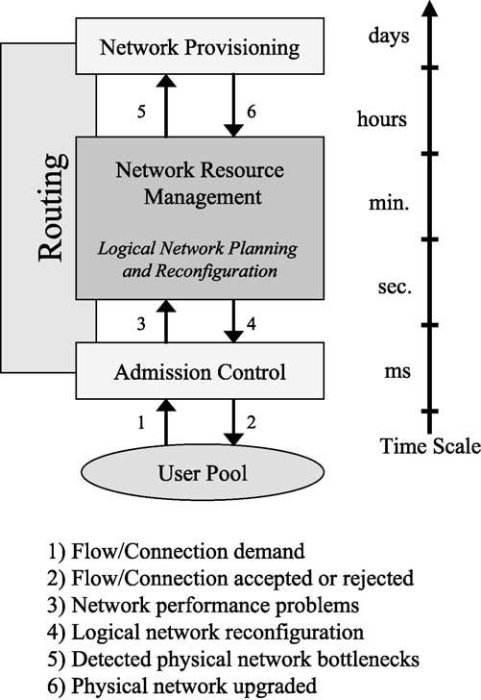
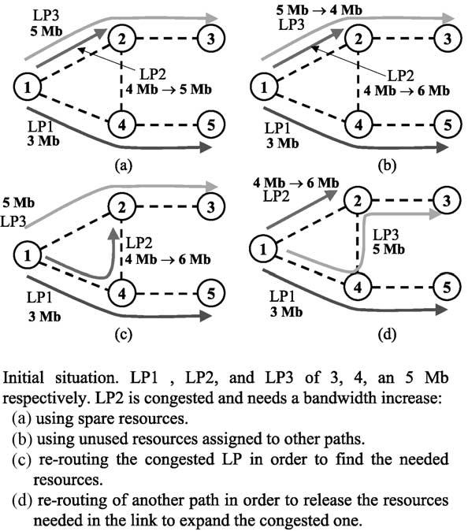

1784

J.L. Marzo et al. / Computer Communications 26 (2003) 1782–1791

Fig. 1). Connections or ﬂows are established through this set
of VPs in ATM, or LSPs in MPLS. In this paper we use both
terms VP and LSP in speciﬁc examples, or the generic term
Logical Path (LP) to refer to any kind of logical path
regardless of the network technology.

3. Network resource management experimentation

This section presents the main mechanisms performed by
the network resource management. Usually these mechan-
isms act on a periodical basis, e.g. every hour. There are also
restoration techniques that must re-route the links affected
by a failure as fast as possible. Therefore, there are also
temporal considerations since some mechanisms act in a
short term, others in a mid-term and others in a long term.
This time scale idea is depicted in Fig. 3.
The three main resource management functions sup-
ported by our distributed simulator are dynamic bandwidth
management, fault protection and spare capacity planning.
These functions are brieﬂy described in Sections 3.1 – 3.3.

3.1. Dynamic bandwidth management

Bandwidth management attempts to manage the
capacities assigned to the different logical paths. Parts of
the network can become under-utilised, and other parts
congested. When this occurs, some connections are rejected
which could be accepted if the trafﬁc loads were better
balanced.

Fig. 3. Network resource management operations.

Fig. 4. Bandwidth management.

One of the main objectives of bandwidth management is
to minimise Call Blocking Probability (CBP), i.e.
the probability that an offered call is rejected due to
insufﬁcient capacity being available for the allocation of the
new call. Two actions are usually performed for the
bandwidth management system: bandwidth re-allocation
and logical path re-routing [9,10].
There are four typical cases, which are shown in Fig. 4. (a)
If there is enough spare bandwidth in the link, then the
congested LP is expanded using this bandwidth. (b) If there is
not enough spare bandwidth and other LPs going through the
same link are under-utilised, it is possible to transfer resources
from one LP to the other. If (a) and (b) fail, then a re-routing is
needed: (c) If the congested LP ﬁnds another path with enough
resources then it can be re-routed. Otherwise, (d) other LPs
may be re-routed through other links in order to free enough
capacity to expand the congested LP.

3.2. Fault protection

The ultimate goal of the protection mechanisms is that
customers do not notice failures. To achieve this fast
restoration, pre-planned schemes based on backup paths are
used [11,12]. However, there are several types of backup
schemes (see Fig. 5), each one better than the others in
particular situations. For this reason, and in order to
minimise the required resources for the backup paths,
many proposals make use of several of these schemes at the
same time in an hybrid approach [13]. This adds yet more
complexity to the management system.

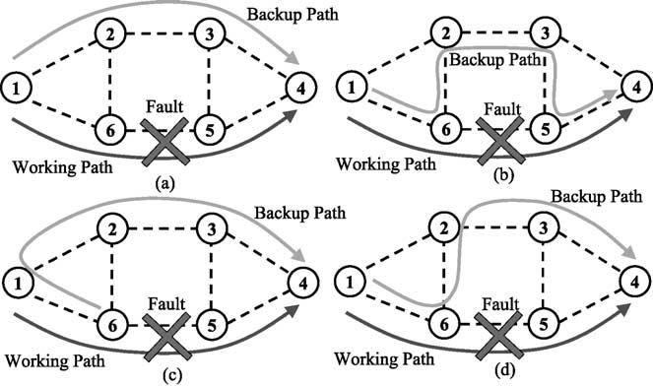
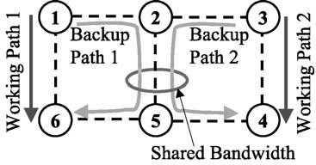

J.L. Marzo et al. / Computer Communications 26 (2003) 1782–1791

1785

Fig. 5. Different backup mechanisms. (a) Global. (b) Local. (c) Reverse. (d)
Hybrid-schemes.
3.3. Spare capacity planning

Network providers want high revenues. Since bandwidth
is an expensive resource, the objective is to minimize
the bandwidth reserved for restoration procedures [14]. In
other words, a good spare-capacity planning is essential.
The main goal of hybrid restoration mechanisms is to save
up spare capacity. It is necessary to establish the desired
network protection level, i.e. protect the network against
one simultaneous link or node failure. In such a scenario,
there is the technique of sharing bandwidth between
different backup paths (see Fig. 6).

3.4. Interrelation of these techniques

Most of the above resource management techniques can
be applied to different kinds of network technologies that
have resource management mechanisms like the ones
detailed in the previous section. These techniques are
usually implemented using distributed and/or centralised
algorithms, and sometimes a proposed system implements
several of these techniques at the same time. All these
techniques modify the logical path network, so they are very
interrelated. For this reason there are several proposed
methods that try to deal with all these techniques
simultaneously, but this usually implies a high degree of
complexity. To cope with this complexity there are many
proposals for network resource management based on
Distributed Artiﬁcial Intelligence (DAI) techniques, i.e.
multi-agent systems (MAS). Examples of distributed
techniques are [15,16], and examples of DAI based
techniques are [17,18].

Fig. 6. Spare Capacity optimization by sharing the bandwidth between
backup paths.

The distributed simulator allows researchers to
implement different resource management techniques
regardless of whether they are centralised and/or distributed
algorithms. The simulator even allows the development of
non-automatic resource management tools, i.e. manual
utilities to manage the resources of the simulated network.

4. Related work

There is a signiﬁcant number of network simulators.
Most of them are general purpose network simulators that
include hundreds of modules. These modules allow the
users to simulate complex networks using different
technologies (wireless, LANs, satellite, etc). Usually these
simulators also have large libraries with models of real
network equipment, implemented protocols, and other.
They also give to the user the ability to develop its own
modules or even to modify the original ones. This huge
ﬂexibility along with the number of modules and libraries
make long and difﬁcult their learning for beginners. These
are typically event oriented simulators at a packet level.
Examples of this type of simulators are OPNET¹and NS-2².
Both simulators where selected in the TEQUILA project | 3  .
NS-2 was selected to test aspects of TE algorithms in the
context intra-domain environments and OPNET was
selected to test inter-domain aspects.
In Ref. [19] the ﬂuid simulation is compared to the
packet-level simulation. In the ﬂuid simulation paradigm,
network trafﬁc is modelled in terms of continuous ﬂuid ﬂow,
rather than discrete packet instances. Our proposal is more
similar to the ﬂuid simulation paradigm than to the packet-
level simulation. This represents a higher level of
abstraction.
The simulation tool presented in this paper is also more
oriented to help developing new management tools. In this
sense it is similar to tools like MIMIC⁴and ALPINE⁵. The
ﬁrst one is based on the simulation of SNMP Agents and it is
also oriented to the development and testing of network
management applications. ALPINE is based on the place-
ment of the networking stack outside the operating system
kernel in order to help the developing and modiﬁcation of
protocols. In this case it is not a simulator because it makes
use of the real network.

5. Simulator design and implementation

The distributed simulator design is based on a
client/server model. A previous version can be found in

1 OPNET URL: http://www.opnet.com
2 NS-2 URL: http://www.isi.edu/nsnam/ns
3 TEQUILA URL: http://www.ist-tequila.org
4 MIMIC URL: http://www.gambitcomm.com
5 ALPINE URL: http://alpine.cs.washington.edu

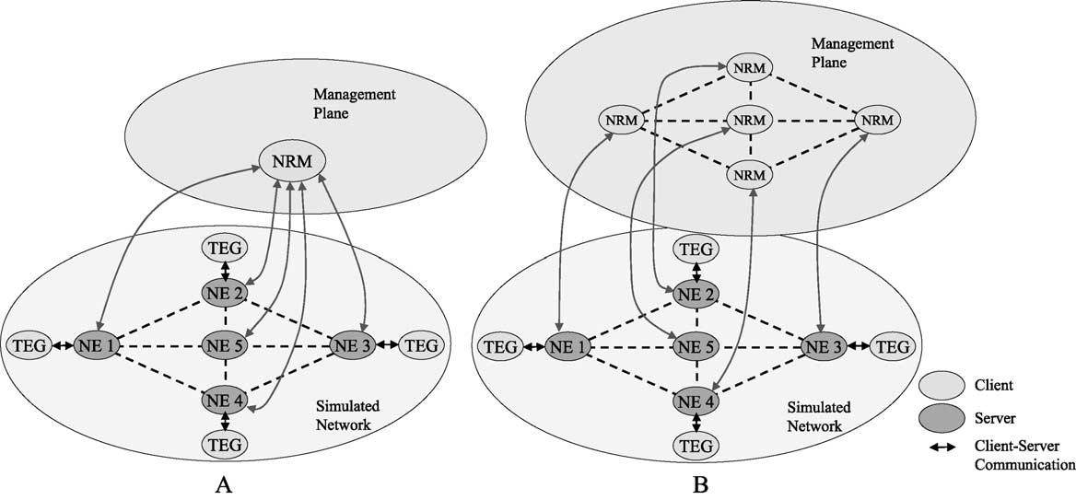

1786

J.L. Marzo et al. / Computer Communications 26 (2003) 1782–1791

Ref. [20]. The server process is called Node Emulator (NE)
and its main function is the emulation of a working network
node. This NE process offers a high functionality to its
clients, which can be of two different types. The ﬁrst type of
client process is the Trafﬁc Event Generator (TEG), that can
be attached to an NE and acts as a pool of users asking
connections or ﬂows to a destination node. The TEG and NE
sets of processes constitute the distributed simulator where
resource management investigation is performed. The
second type of client processes is the network resource
management algorithms. TEG and management client
processes, access to the server (NE) functionality through
its Application Programming Interface (API). This API
offers a set of functions to perform the node management,
and allow the checking and modiﬁcation of the node internal
status. The API also has several TEG-oriented functions,
which are detailed later.
Performing a network simulation with a certain number
of nodes implies the use of the same number of NE server
processes, which can be in the same or in different
computers. This is due to the use these processes make of
the TCP/IP socket interface. Both the NE and TEG
processes are implemented in Cю ю and can be executed
in a Sun workstation under Sun Solaris OS, as well as in a
PC under Linux OS.
Network resource management algorithms also have to
be implemented as client processes. Thus it is possible to
implement a centralised resource management algorithm or
a distributed one, as it is shown in Fig. 7.
Generally there is no communication among NE
processes unless a speciﬁc routing protocol is implemented.
The default routing protocol takes into account the direct
path only. However, the default routing and admission
control protocols can be changed through the modiﬁcation
of the NE source code. These changes are relatively easy to
do due to the modular object oriented simulator design, and
its clear documentation.

The TEG processes are able to send events to the NE
processes. The deﬁned events include ‘connection-demand’
and ‘connection-release’, to establish new connections
or ﬂows and to release existing ones, respectively.
The generation of these events follows a parameterized
distribution, e.g. a negative exponential distribution, thus
the trafﬁc load is independently conﬁgurable for every node.
Moreover it is possible to attach more than one TEG process
to the same NE.
There are three additional types of events which can be
generated by the TEG process. The ﬁrst one is called
‘Instantaneous-BW’ and for every established connection or
ﬂow, during its life span, the TEG process can generate this
type of events to inform the NE of the real bandwidth used
in that connection or ﬂow. This type of events can also
follow several different parameterised distributions. The
second and third events are the ‘Link-failed-notice’ and the
‘Link-restored-notice’, and they are used to inform an NE
process to mark a physical link as failed or as a working link
again. This is used to simulate link failures on the physical
network. There is also a mechanism in the NE processes to
send an alarm notiﬁcation to the network resource manage-
ment processes in case a link is marked as a failed link.
The different TEG processes are independent and all of
them can be conﬁgured with different parameters. The TEG
processes are not only used for the connection/ﬂow
distribution and connection/ﬂow duration, but also to
generate the different quality of service requested on each
connection/ﬂow and the selection of the destination node.
These characteristics can also be set to conﬁgure, for
example, a TEG to generate only one type of
connection/ﬂow with one speciﬁc destination node.
The simulated physical network is static and cannot
change during the simulation. Moreover, all the NE
processes read the physical network structure from the
same conﬁguration ﬁle. It is possible to set up an initial
logical path network in the same common conﬁguration ﬁle.

Fig. 7. Distribution of client and server processes. (A) Centralised management case. (B) Distributed management case.

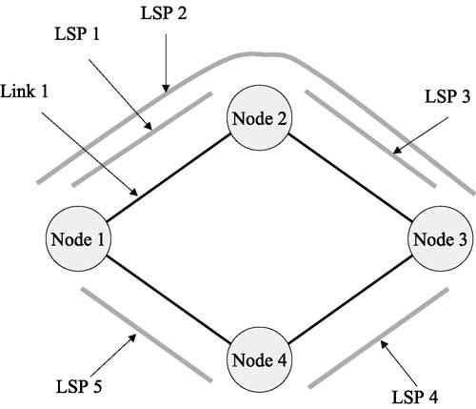
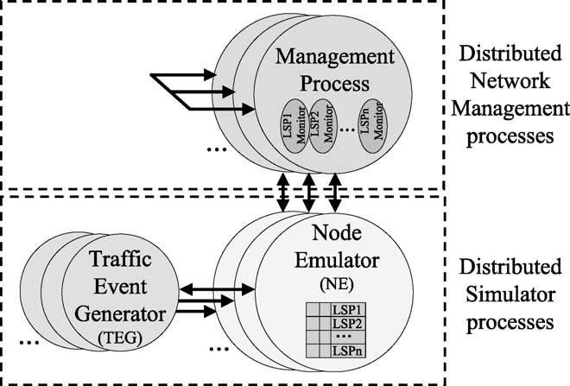

J.L. Marzo et al. / Computer Communications 26 (2003) 1782–1791

If there is no kind of network resource management, the
logical path network also remains static. The network
resource management algorithms are not part of the
simulation platform; they can be developed in any language
on any platform and can be executed on the same or
different computers from where the simulation processes are
being executed. As it can be deduced, if the network
resource management is implemented as a distributed
algorithm, the communication among the management
processes can use mechanisms or technologies different
from the TCP/IP socket interface, e.g. CORBA⁶or Java
RMI⁷, allowing the implementation of many different types
of management applications.
Every NE process generates a log ﬁle with all the

1787

functions and parameters that have been requested by the
TEG(s) processes and/or the management process attached
to it. From the analysis of this set of log ﬁles it is possible to
extract the results and even to reproduce the complete
simulation. These log ﬁles are based on formatted text and
they can also be directly loaded into spreadsheet programs
or statistic packets.
An important characteristic is the simulator scalability in
terms of the number of nodes that can be simulated. The
simulation processes can be distributed in several computers
and moreover they are executed in parallel. The main
constrain is the client – server communication, but the use of
an isolated network (e.g. 100 Mbps Ethernet) allows the
achievement of a relatively high performance. For instance,
if the TEG clients are strategically placed in the same
computers than the NE processes they are attached to, and
then there is no communication between the computers
(with the default CAC and routing conﬁguration). In this
case, the only process communication comes from the
network management algorithm being tested or developed.
Therefore, in such case the scalability do not depend on the
simulator but on the management system.

6. Simulation examples

This section presents simple scenarios to show how the
simulator works and the different type of applications that
can be performed using it. In some cases they are just
demonstration examples, and in other cases they are part of
our ongoing research.

6.1. Dynamic bandwidth management

This section describes a dynamic bandwidth manage-
ment experiment in an MPLS domain. The scenario presents
a simple four-node network, where several LSPs are
established as is shown in Fig. 8. In this example, a
distributed algorithm based only on local information is

6 CORBA URL: http://www.corba.org
7 Java URL: http://java.sun.com
Fig. 8. Four-node network with the established LSPs.

tested. This distributed algorithm monitors the LSPs on
every node. More speciﬁcally, there is a management
process that monitors the LSPs that begin on a given node
and calculate the CBP, i.e. the probability of a ﬂow being
rejected in the ingress LSR, for every LSP.
If a certain CBP threshold is achieved, then the
dynamic management process on that node asks the other
involved nodes for bandwidth re-allocation, or if it is not
possible, for LSP rerouting. The necessary information is
sent to other nodes by means of a developed application
protocol. In this speciﬁc example the dynamic manage-
ment and the monitoring processes were implemented
using Java and interacted with the simulated nodes using
their API (a Java package implementing an easy-to-use
communication interface between an NE process and a
Java application was also developed). The structure is
presented in Fig. 9.
The distributed algorithm tested bases the decision of
performing a logical network reconﬁguration using only
information that the node has locally. Moreover, no
management process performs a reconﬁguration of the
whole logical network; each management process at each
node only manages the resources on that node. Of course,

Fig. 9. The different processes involved in the simulation example and the
communication between them. On every Management process there are
several threads each one monitoring an LSP.

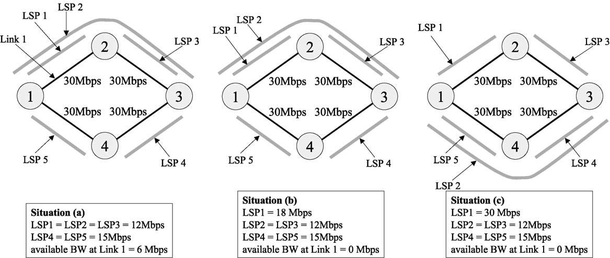
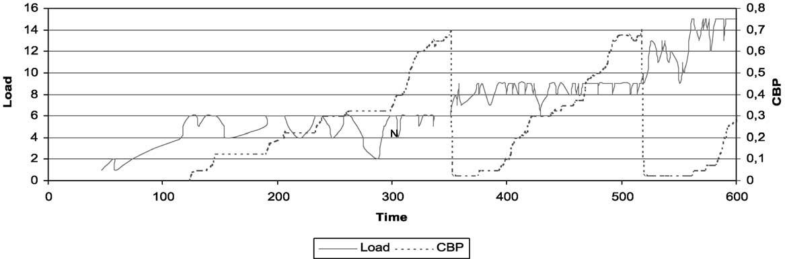

1788

J.L. Marzo et al. / Computer Communications 26 (2003) 1782–1791

Fig. 10. LSP network changes due to the bandwidth management mechanisms.

once the decision is made, the management process on that
node must co-ordinate the changes with the rest of the
affected nodes.
Fig. 10 shows the three different network situations in the
course of the simulation. The main idea of this example
experiment is that the ﬂow demand from node 1 to node 2,
which makes use of the LSP1, constantly increases. This
means that an LSP reconﬁguration will be required to adapt
the logical network topology to the new demand. First of all,
the management processes try to expand the bandwidth
assigned to an LSP without changing the logical network
topology. This can be achieved using free bandwidth from
the link and/or reducing the bandwidth of other LSPs that
are not full. In this particular experiment this action is
performed for the ﬁrst time when a CBP of 70% is reached
on LSP1. After that, more ﬂows can be accepted in LSP1,
but as the user demand keeps increasing, once again a CBP
of 70% for LSP1 is reached. In this case there is no more
free bandwidth in link 1, and the management process
decides to change the LSP2 and re-route it through node 4
instead of through node 2. Therefore, free bandwidth is
released in link 1 and LSP1 capacity can be expanded to the
maximum capacity of the link.

This simple experiment shows how the management
process at node 1 adapts the logical network in order to
accept more ﬂows from node 1 to node 2. Doing this
dynamic resource management means that a better
network performance is achieved, i.e. the same resources
are better utilised. Without this resource management, in
a static logical network scenario, more ﬂows would have
been rejected. Fig. 11 also displays a graph including the
LSP1 load, i.e. number of connections (left y-axis), and
the LSP1 CBP (right y-axis) versus time.
Note that the demanded ﬂows are homogeneous (2 Mbps
each) so before the ﬁrst change, LSP1 can accept a
maximum of 6 connections (LSP1 ј 12 Mbps). Between
the ﬁrst and second change, LSP1 can accept 9 connections
(LSP1 ј 18 Mbps) and after the second change it can
accept 15 connections (LSP1 ј 30 Mbps). The LSP1
bandwidth changes are made when the CBP reaches 70%
in this particular experiment.

6.2. Evaluating a function to detect congestion

The experiments presented here were carried out in order
to evaluate different mechanisms for the identiﬁcation of

Fig. 11. Load and CBP versus time for the LSP 1.

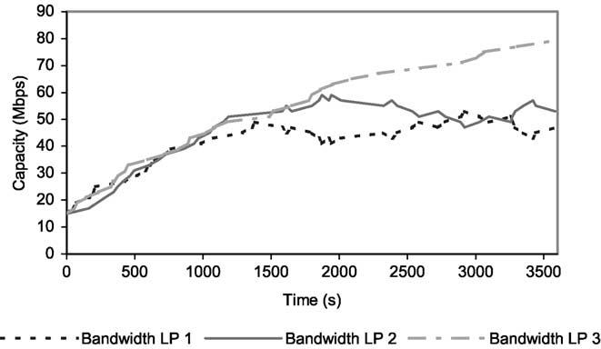
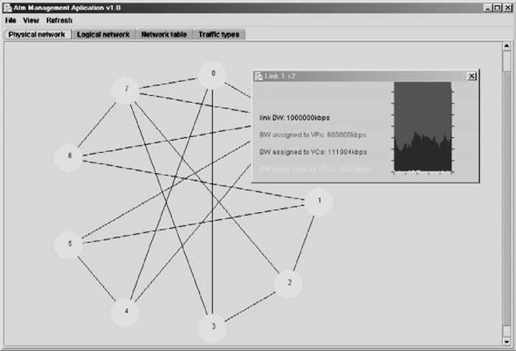

J.L. Marzo et al. / Computer Communications 26 (2003) 1782–1791

congested logical paths. An interesting problem is how to
ﬁnd out if an LP is congested. Each node has a
monitoring agent (or M-Agent), that periodically performs
a monitoring function over a single logical path (a time
interval of 10 s for these experiments) and it decides
whether the LP is congested or not. If the LP is
considered to be congested, then the M-Agent triggers
the mechanism for increasing the bandwidth of the LP by
taking spare resources from the link. If this is not
possible, the system tries to allocate unused resources that
are already assigned to other LPs (using a pre-emptive
policy). In the proposed scenario the management system

1789

do not utilize the LP re-routing functions for reasons of
clarity and only the bandwidth re-allocation is used.
In this case the management system was build as a
distributed system based on a MAS. We also use Java
for the management system, and the communication
among the agents was through RMI as in the previous
example.
The triggering mechanism is called ‘Trigger Function’
and we have evaluated three different functions:

(a) Rejected-5: If the 5 last consecutive connection or ﬂow
requests for a given LP are rejected, the LP is
congested.
(b) CBP-70: The CBP is calculated using the last 30
connection or ﬂow requests. If the CBP is greater or
equal to 70%, the LP is congested.
(c) Load-90: If the load of the LP is greater or equal to
90% of its capacity, then it is congested.

The simulated network for the experiments had 4
nodes and a similar conﬁguration that the previous
example. Each physical link had 100 Mbps of capacity.
There were 10 unidirectional LPs with an initially
assigned capacity of 15 Mbps. All LPs had the same
offered trafﬁc load (speciﬁed in Table 1). Using negative
exponential distributions for the interarrival time and
duration, the mean load for each LP is 100 Mbps, hence
all links tend to be congested.
The amount of bandwidth by which to increase an LP
every time the Trigger function detects congestion was
ﬁxed to 2 Mbps. The simulation time was 1 h in each
case and the general behavior, shown in Fig. 12, was as
follows: In the case of a single LP per link, this LP

Table 1
Trafﬁc offered for each LP
Trafﬁc class Assigned bandwidth Mean interarrival Mean duration(s)
time(s)
Fig. 12. Capacities assigned to LPs beginning in node 1 (LPs 1, 2, and 3),
using the Trigger function Reject-5 and every change of bandwidth is of
2 Mbps.

increased its bandwidth up to near the maximum level of
the link (LP 3 in Fig. 12). In the case of two LPs per
link they increased their bandwidth until they reached
half of the link capacity and then they competed for
bandwidth (LPs 1 and 2 in Fig. 12).
The results comparing the three trigger functions show
signiﬁcant differences. It is possible to ﬁnd more details in
[21], where this speciﬁc experiment was presented.

6.3. Using a centralised monitoring application

In this case we developed a centralized management
application, in order to test the possibilities of the simulated
network. This management application polls periodically all
the nodes in the network asking for their complete data.
Thus, this application allows visualizing the load of every
link and every LP in the network. Moreover, this application
also allows the modiﬁcation of the logical network
manually, i.e. establish and release LPs and change their
capacities.
This application was built using the ATM terminology as
a graphical utility. Fig. 13 shows a window capture

1
2
3
4
5

64 Kbps
2 Mbps
2 Mbps
4 Mbps
10 Mbps

2
10
20
30
100

60
120
300
120
300

Fig. 13. Window capture showing the managed physical network and a
monitoring window for one link.

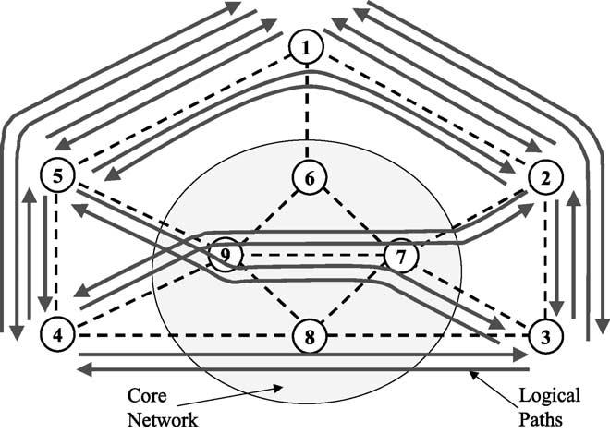
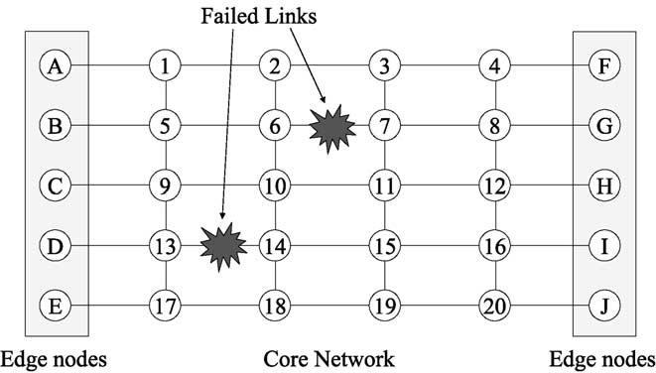

1790

J.L. Marzo et al. / Computer Communications 26 (2003) 1782–1791

The faults are not simultaneous and the ﬁrst to occur is the
link 6 – 7 (not the 7 – 6). Node 6 detects the fault (NE 6 sends
the alarm to the management application) and sends alarm
messages to every edge node that has an LP going through
link 6 – 7 (all this happens at the management application
level). Then the edge links send messages along the backup
LPs to capture the required bandwidth and switch the
established connections from the original LPs to the backup
ones. When the fault is corrected, and the link 6 – 7 is
working again, there is a similar mechanism that moves
back the connections to the original LPs.

7. Conclusions and future work

Fig. 14. Simulated network. Only the 5 edge nodes (1 – 5) had an associated
TEG process.
displaying the physical network topology and monitoring a
physical link. Again this centralized management appli-
cation was build using Java and it maintains open
communication sockets with all the nodes of the simulated
network. Fig. 14 shows the simulated network for this
experiment, which had 9 nodes and 16 physical links.

6.4. Implementation of a pre-planned restoration
mechanism

This example shows a simple experiment where we have
implemented a pre-planned restoration mechanism. This
mechanism detects the fault alarms generated by the nodes,
and switches the established connections from the affected
LPs to their corresponding backup LP. This example was
also utilised to perform the simulation distributing the
processes into three different computers.
Fig. 15 presents the simulated network. There are 30
nodes (10 on each computer) of whom 10 represent
edge nodes. There are 50 established LPs connecting
every edge node from the left side (A – E) to all the nodes
on the right side (F – J) and vice versa. There are also 50
backup LPs protecting the working ones, which utilise a
global scheme. The original size of the backup LPs is zero.

Fig. 15. Simulated network for the restoration test. Every line represents
two unidirectional links, one in each direction.

This study has presented a distributed simulation
platform able to perform a wide range of experiments
related to network resource management. There is a large
amount of network simulation platforms, but the one this
paper presents has demonstrate its versatility and scalability
while maintaining its simplicity and ease of use. This
simulator tool is designed to test and develop network
resource management applications. The initial objective of
designing a very ﬂexible and conﬁgurable platform, while at
the same time maintaining its modularity, was also achieved
by the use of client/server architecture.
At present, the simulation processes have been fully tested
and are operative, and we plan to use it for a lot of experiments
related to the research being carried out in our group. We are
now developing several other network resource management
mechanisms to be tested using the distributed simulator.
These algorithms allow us to ﬁnd possible bugs and also
introduce new functionality in the simulator.
As a future work on the distributed simulator itself there
are three deﬁned lines to follow. First of all we plan to
develop a visual tool to make the network topology
deﬁnition easier and automate the generation of the
conﬁguration ﬁles and the distribution of the simulation
processes over several machines and the starting of a
simulation. Second, we plan the development of an
automatic tool to process the log ﬁles generated for every
node. This tool could perform the merge of the several log
ﬁles and generate statistics and extract complex results.
Finally these log ﬁles could also be used to perform a debug
task of network management mechanisms and even debug
the simulator itself. This last point is a long-term idea but we
think it could be interesting to transform a simulation tool
into a debugging tool for network management algorithms.

Acknowledgements

This work was partially supported by the Spanish
Research Council (CICYT) under contract TEL-99-0976.
The authors would like to thank the members of the BCDS
group (University of Girona) for their useful comments.

J.L. Marzo et al. / Computer Communications 26 (2003) 1782–1791

1791

References

[1] D.J. Sidor, TMN standards: satisfying today’s needs while preparing
for tomorrow, IEEE Communications Magazine March (1998).
[2] W. Stallings, SNMP and SNMPv2: the infrastructure for network
management, IEEE Communications Magazine March (1998).
[3] J.L. Marzo, P. Maryni, P. Vila`, Towards QoS in IP-based core
networks. A survey on performance management, MPLS case,
Proceedings of International Symposium on Performance Evaluation
of Computer and Telecommunication Systems, SPECTS’2001,
Orlando, Florida (USA) July (2001).
[4] G. Armitage, MPLS: the magic behind the myths, IEEE Communi-
cations Magazine January (2000).
[5] X. Xiao, A. Hannan, B. Bailey, L.M. Ni, Trafﬁc engineering with
MPLS in the Internet, IEEE Network Magazine March (2000).
[6] L. Andersson, P. Doolan, N. Feldman, A. Fredette, B. Thomas, LDP
Speciﬁcation, RFC 3036, www.ietf.org.
[7] J.-Y. Le Boudec, The asynchronous transfer mode: a tutorial,
Computer Networks and ISDN Systems 24 (4) (1992).
[8] E.D. Sykas, K.M. Vlakos, M.J. Hillyard, Overview of ATM networks:
functions and procedures, Computer Communications 14 (10) (1991).
[9] V.J. Friesen, J.J. Harms, J.W. Wong, Resource management with
virtual paths in ATM networks, IEEE Network 10 (5) (1996).
[10] K.-I. Sato, S. Ohta, I. Tokizawa, Broad-band ATM network
architecture based on virtual paths, IEEE Transactions on Communi-
cations 38 (8) (1990).
[11] R. Kawamura, H. Ohta, Architectures for ATM network
survivability and their ﬁeld deployment, IEEE Communications
Magazine (1999).
[12] T. Yahara, R. Kawamura, Virtual path self-healing scheme based on
multi-reliability ATM network concept, IEEE GLOBECOM’97
November (1997).

[13] E. Calle, T. Joveґ, P. Vila`, J.L. Marzo, A dynamic multilevel MPLS
protection domain, Third International Workshop on Design of
Reliable Communication Networks, DRCN, Budapest (Hungary)
(2001).
[14] Y. Xiong, L.G. Mason, Restoration strategies and spare capacity
requirements in self-healing ATM networks, IEEE/ACM Trans-
actions on networking 7 (1) (1999).
[15] S.-O. Larsson, A. Arvidsson, A study of a distributed approach for
VPC network management, IEEE GLOBECOM’97 Global Tele-
communications Conference—Phoenix (USA) November (1997).
[16] S.-O. Larsson, A. Arvidsson, in: P. Key, D. Smith (Eds.), An adaptive
local method for VPC capacity management, ITC 16, Elsevier,
Amsterdam, 1999.
[17] Z. Luo, J. Bigham, L.G. Cuthbert, A.L.G. Hayzelden, Trafﬁc control
and resource management using a multi-agent system, Fifth
International Conference on Broadband Communications, Hong
Kong (China) November (1999).
[18] J.L. Marzo, P. Vila`, R. Fabregat, ATM network management based on
a distributed artiﬁcial intelligence architecture, Fourth International
Conference on Autonomous Agents, AGENTS’2000, Barcelona,
(Spain) June (2000).
[19] B. Liu, D.R. Figueiredo, Y. Guo, J. Kurose, D. Towsley, A study of
networks simulation efﬁciency: ﬂuid simulation vs. packet-level
simulation, Proceedings of INFOCOM, Anchorage, Alaska, USA
April (2001).
[20] J.L. Marzo, P. Vila`, L. Fa`brega, D. Massaguer, An ATM distributed
simulator for network management research, Proceedings of 34th
Annual Simulation Symposium, ASS’2001, Seattle, Washington
(USA) April (2001) 185 – 192. IEEE Computer.
[21] P. Vila`, J.L. Marzo, E. Calle, Dynamic bandwidth management as part
of an integrated network management system based on distributed
agents, IEEE GLOBECOM, Taipei (Taiwan) November (2002).

